**SLOT MACHINE APP**

**Technologies:** ES6, HTML, CSS, Webpack, Babel, Docker API, Visual Studio Code, GitHub

Download the app from github link.

<https://github.com/derik09/SlotMachineApp>

Docker API needs to be running as <http://localhost:8888/serve> or the port you are using.

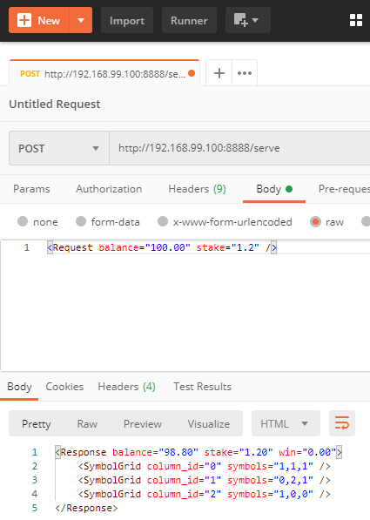

Used the docker API , provided by you. On each spin the first element of each symbol grid is sliced and mapped with the fruits. For example, in above figure 1, 0, 1 is taken from each of the first three inner elements and displayed as banana, apple, banana.

Run :> npm start

App would be build on local and could be browsed at link localhost:8080/ or whichever link appears in your node cli

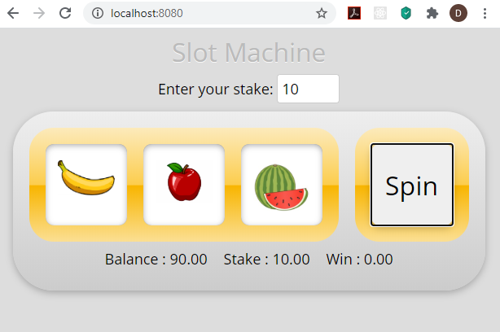

Stake amount can be changed within the enter your stake textbox. Balance is hardcoded at the moment at 100. Could modify it if required.

For animations used code from animate.css , see below link.

<https://animate.style/#javascript>

For sound used below file, but commented as sound is heard everytime Spin button is clicked.

<audio id="audio" src="http://www.soundjay.com/button/beep-07.wav"></audio>

## **Review Criteria**

* **Modular/Code organization.**

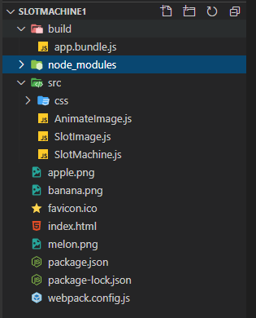

All Js files and css files are under the src folder. Have used babel and webpack to bundle all js files into es5 compatible file - build/app.bundle.js.



The Slotmachine.js is set as the entry point.

Separated out animate.js, image.js and slotmachine.js into classes and imported accordingly.

* **Generic where appropriate.**

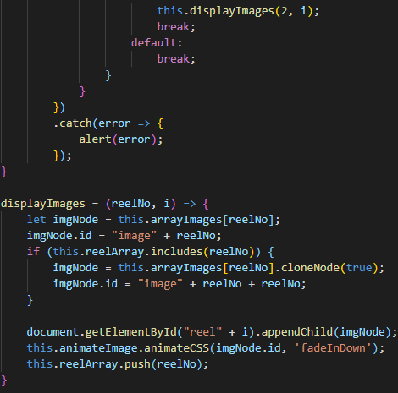

Combined common functionality into displayImages method

* **Use of inheritance.**

Not much scope to implement, but divided files into modules and called functions of different classes

* **Clarity/Self documenting.**

Added comments wherever necessary.

* **Indenting.**

Developed app in Visual Studio Code. Shortcut Key => Ctrl + K + D used for indenting code.

* **Use of camel case.**

Used within the code.

* **Demonstrate understanding of JS scope.**

Used global and local variables. For example, an arrayImages global variable that is used by different methods.

* **Optimised code.**

Webpack and Babel used to bundle all javascript files into backward compatible files (from es6 to es5). Since javascript is minified into app.bundle.js (es5) , javascript would work in all browsers

* **Use of callbacks / timers.**

Tried using async/await, but was getting error that it could be used in only .ts files. I am not using any typescript code here for the same.

* **Error Handling.**

Error handling is maintained as below. Error from Docker web api is taken care of as well.

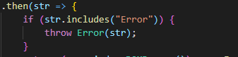

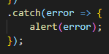

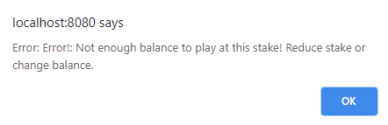

* **Responsive design handling for small screen**

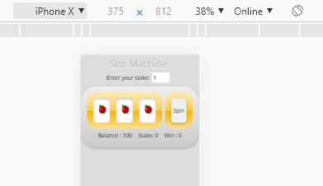

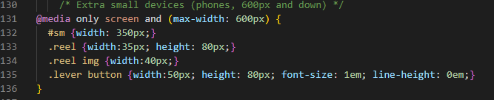

**THANK YOU**